Kony Fabric Single Container Solution (On-Premises)

Release V8 SP4 FP3 HF4 GA

1. Prerequisites

1.Install Java 11.

32Install an external Database (MySQL 5.7)

* <https://downloads.mysql.com/archives/get/p/23/file/mysql-5.7.26-macos10.14-x86_64.dmg>

Please ensure that MySQL appearance on system preference after installed MySQL

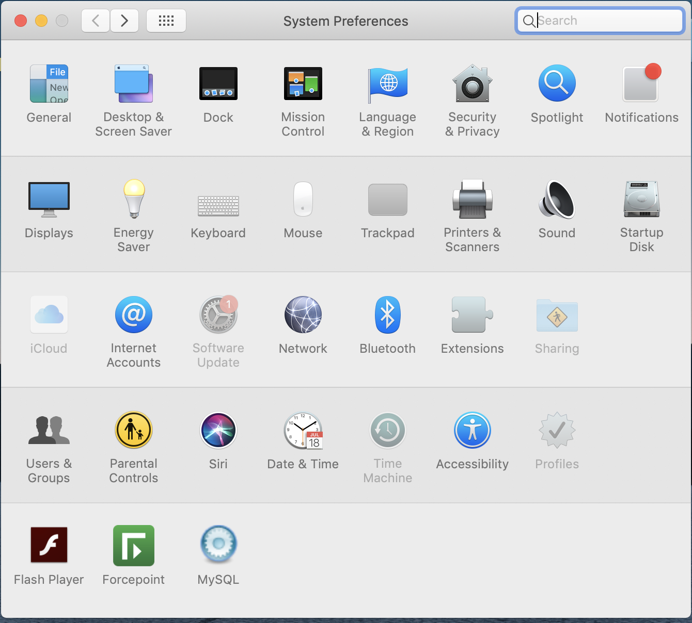

Start SQL server instance

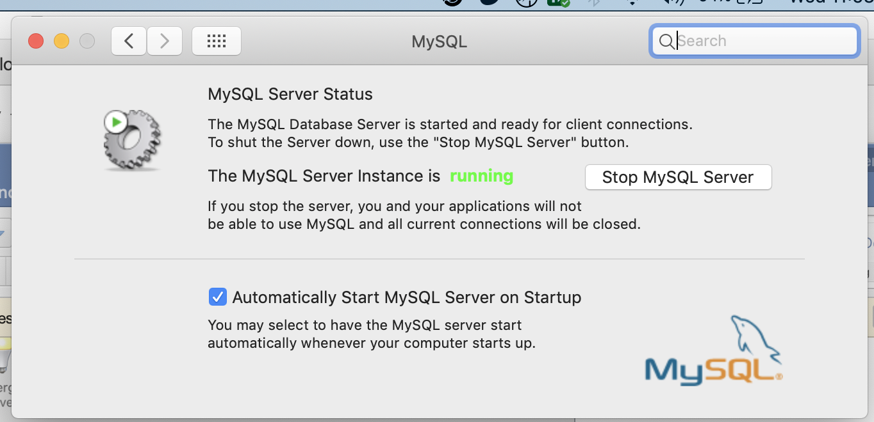

3.Install MySQL Workbench

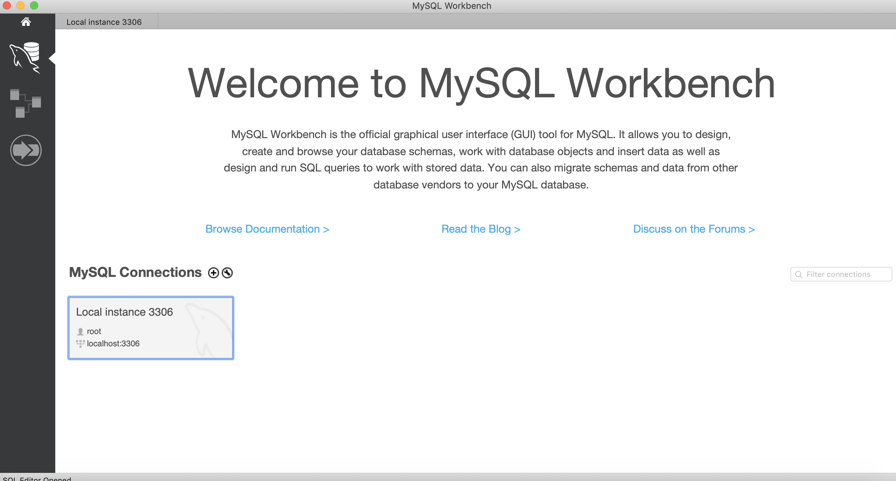

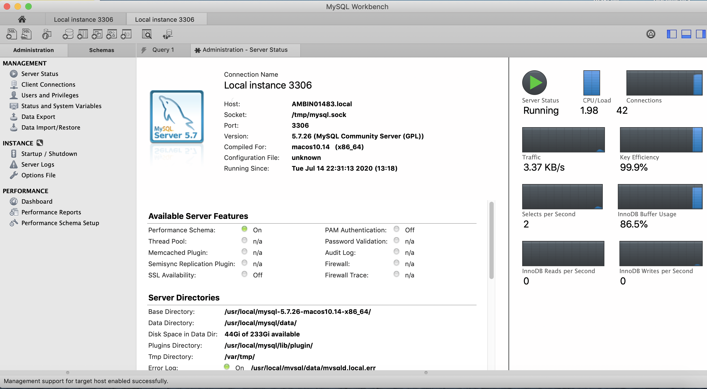

1. Please ensure the **"character-set-server"** and **"default-character-set"** parameters are set to ***'utf8'***

To check, Please run the below queries on **MySQLWorkbench.**

***show variables like "%character%";*** ***show variables like "%CHAR%";***

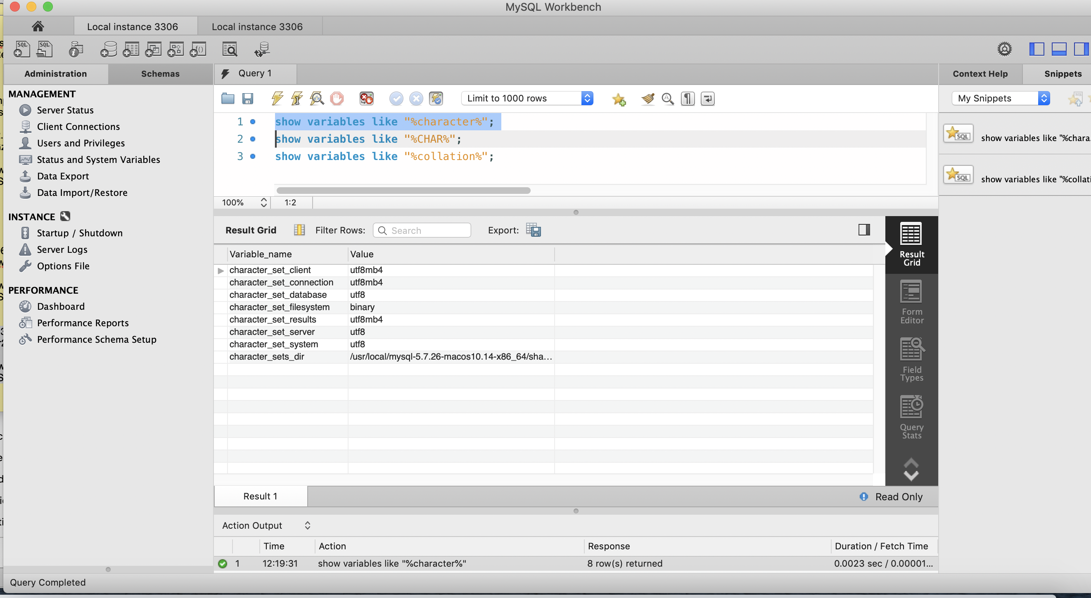

1. Please ensure the **"collation-server"** to **'utf8_unicode_ci'**

***show variables like "%collation%";***

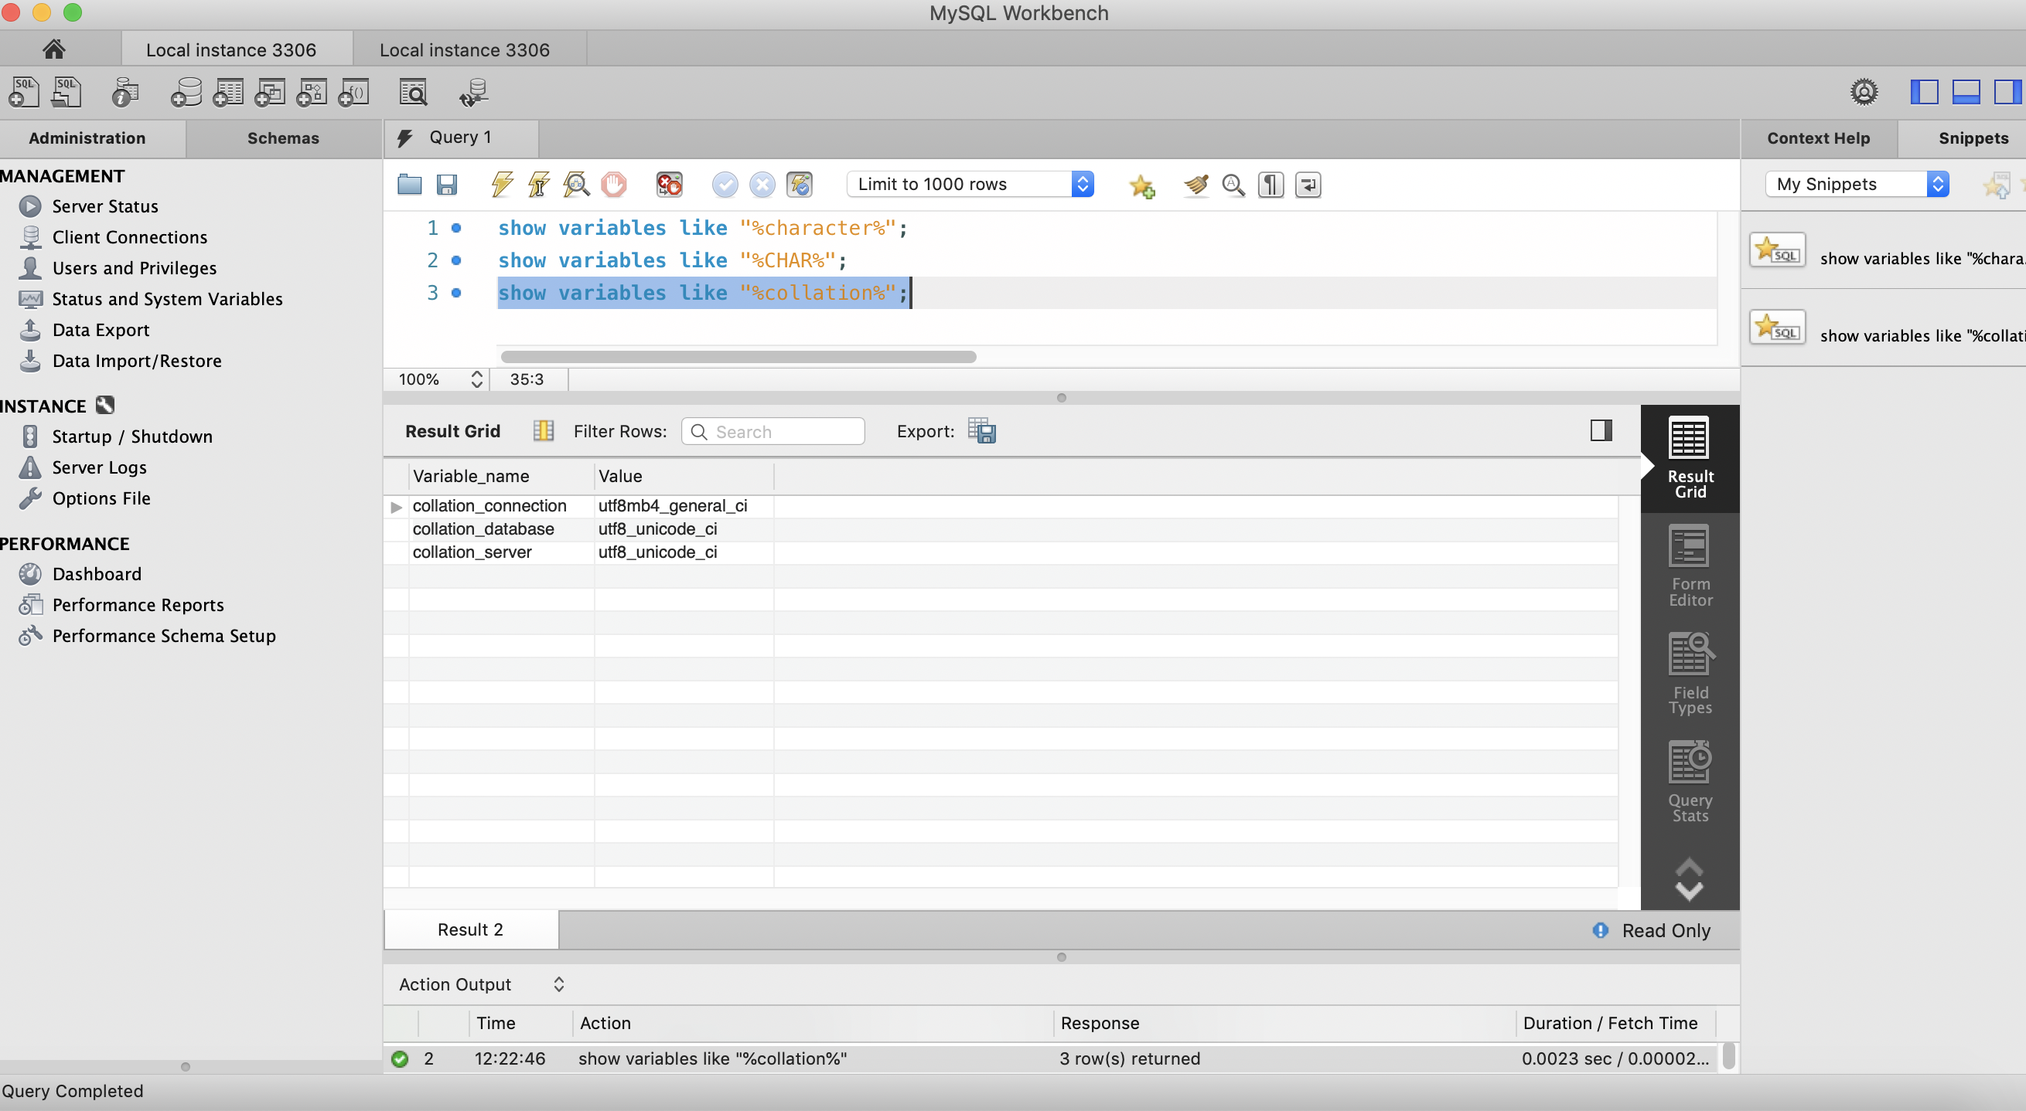

1. Please create user and provide administrative roles and assign % to **Limit to Hosts Matching** for wildcard

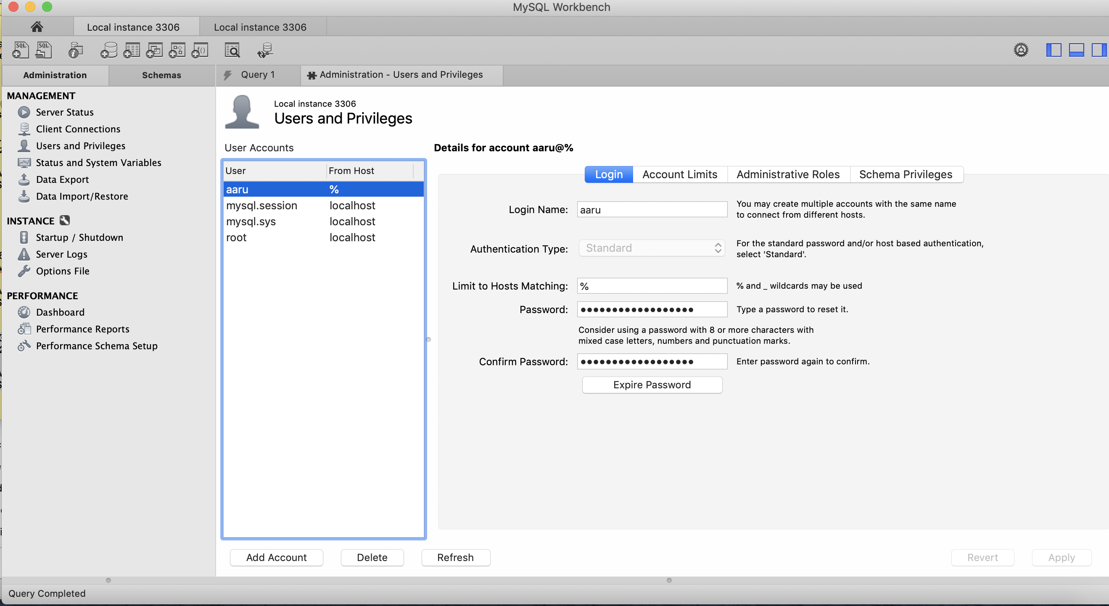

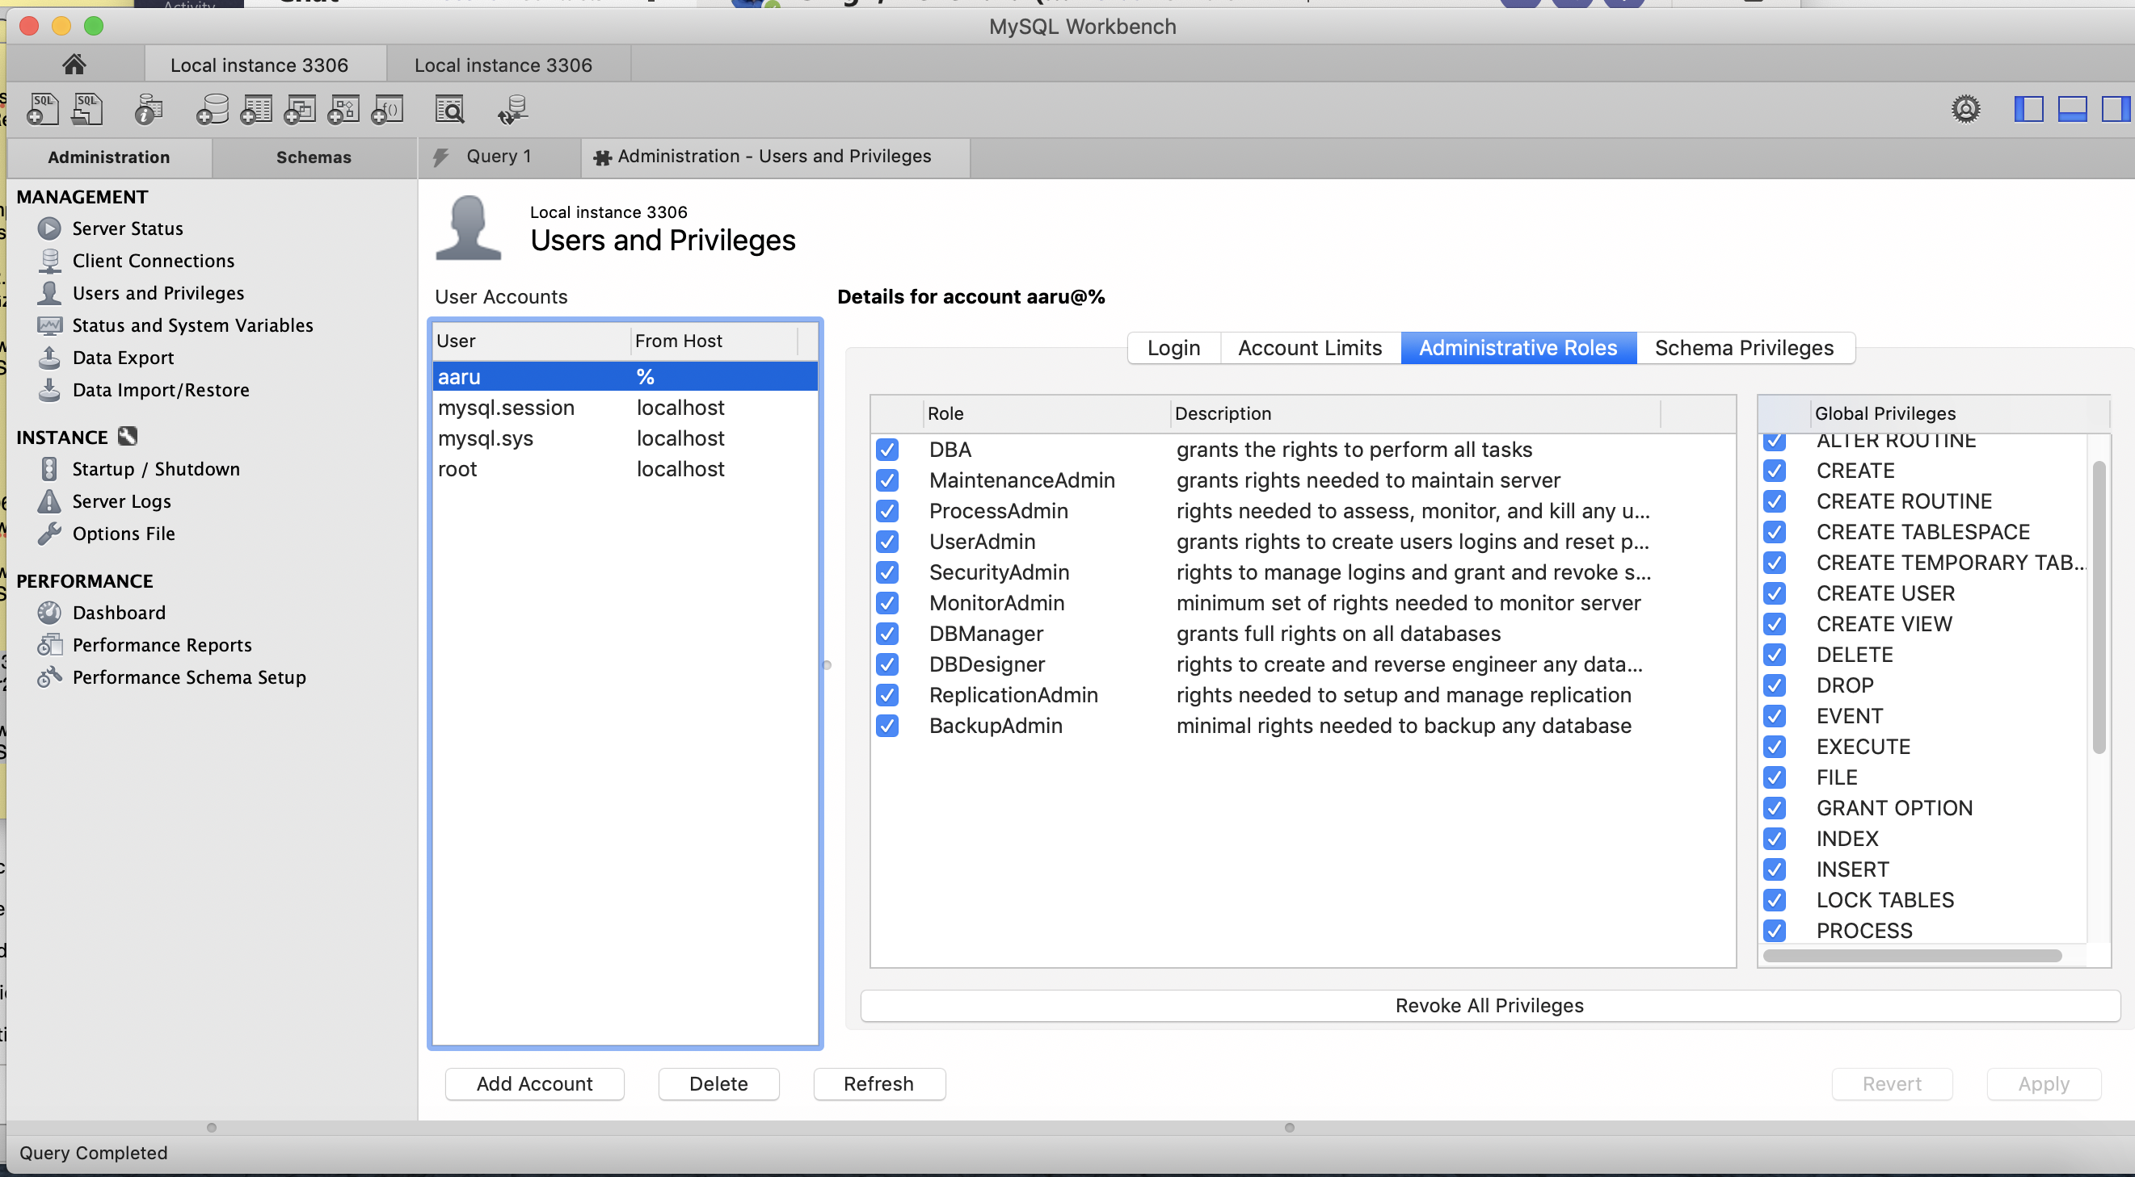

4. Download Mobile Fabric Single Container

<https://community.kony.com/download-product/field_product_download_link/24093/24094>

5.Install Docker Desktop

<https://docs.docker.com/docker-for-mac/install/>

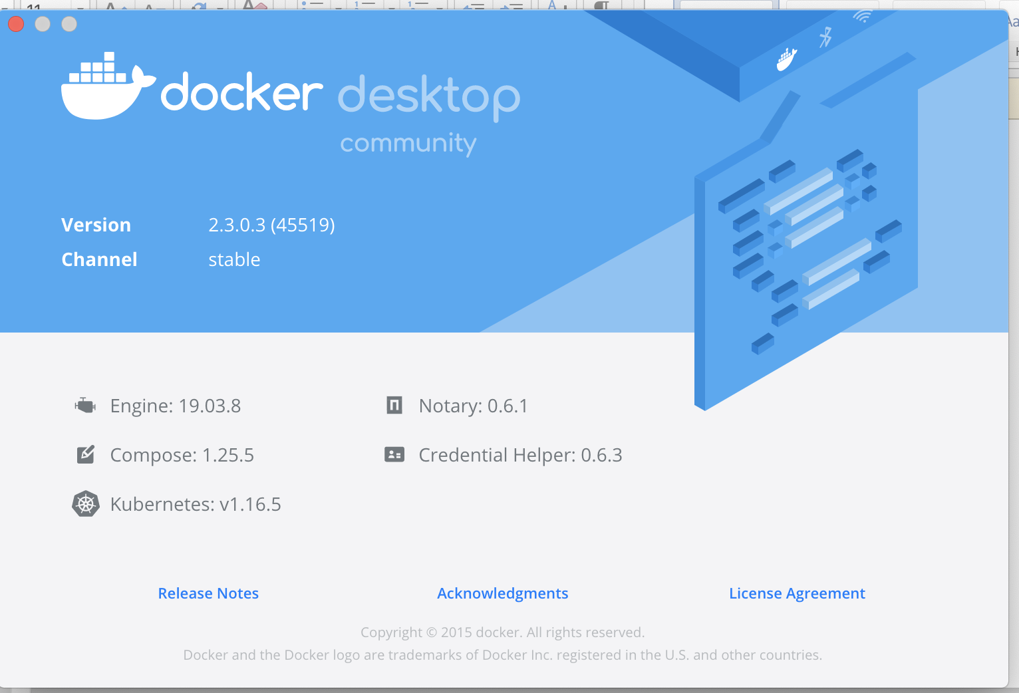

**Installation Steps**

* Once Docker installed, Open Terminal and run the below commands

**docker pull konyfabric/kony-fabric-db:8.4.3.4_GA**

**docker pull konyfabric/kony-fabric-all:8.4.3.4_GA**

* Now Go to KonyFabricSingleContainer-8.4.3.4_GA in Terminal

AMBIN01483:~ 761735$ cd /Users/761735/Aaru/KonyPlatform/Softwares/KonyFabricSingleContainer-8.4.3.4_GA

AMBIN01483:KonyFabricSingleContainer-8.4.3.4_GA 761735$ /Users/761735/Aaru/KonyPlatform/Softwares/KonyFabricSingleContainer-8.4.3.4_GA/install-fabric.sh

Please enter following details

==============================================================

**Installation Details**

--------------------------------------------------------------

Install Environment name: dev

==============================================================

**Application Server Details**

--------------------------------------------------------------

Domain Name: 192.168.1.3

Server Port: 12321

==============================================================

**Database details**

--------------------------------------------------------------

**Select database type**

1) MySQL

2) SQLServer

Please select database server: 1

Database Hostname: 192.168.1.3

Database Port: 3306

Database Username: aaru

Database Password:

Database Prefix: kony

Database Suffix: db

Use existing databases from a previous Kony Fabric instance? (Y/N): n

==============================================================

**Kony Fabric Account Registration Details**

--------------------------------------------------------------

User Id: arumugam.t@cognizant.com

Password:

First Name: Arumnugam

Last Name: T

Environment Name: KonyTraining

--------------------------------------------------------------

**This is the time zone your database is running on. This input is a string of the format Etc/UTC.**

**For determining what value to set for your time zone, please refer https://en.wikipedia.org/wiki/List_of_tz_database_time_zones**

Time Zone: Asia/Kolkata

Jul 14, 2020 11:49:22 PM com.konylabs.middleware.common.ServerPropertiesUtil <init>

INFO: Reading the properties file

Jul 14, 2020 11:49:22 PM com.konylabs.middleware.common.ServerPropertiesUtil <init>

INFO: Reading the properties file

Jul 14, 2020 11:49:23 PM com.konylabs.middleware.common.ServerPropertiesUtil <init>

INFO: Reading the properties file

188a4383bdc7

"docker rm" requires at least 1 argument.

See 'docker rm --help'.

Usage: docker rm [OPTIONS] CONTAINER [CONTAINER...]

Remove one or more containers

Pulling flyway ... done

Creating flyway_flyway_1 ... done

**Waiting for DB migrations to complete (this may take upto 10 minutes)...**

openjdk version "11.0.2" 2019-01-15

OpenJDK Runtime Environment (build 11.0.2+9-Debian-3bpo91)

OpenJDK 64-Bit Server VM (build 11.0.2+9-Debian-3bpo91, mixed mode, sharing)

**DB migrations complete.**

Pulling tomcat ... done

Creating network "fabric_default" with the default driver

Creating fabric_tomcat_1 ... done

**Waiting for Kony Fabric server to start up for Auto Registration...**

**Fabric server startup complete.**

--------------------------------------------------------------

**Auto Registering user with given credentials...**

Response code of POST api/v1_0/accounts/config/onebox: 200

Kony Fabric environment registration successful.

Admin account details are

First Name : Arumnugam

Last Name : T

Email : arumugam.t@cognizant.com

--------------------------------------------------------------

Kony Fabric cluster is created successfully.

Below are the App URLs:

Kony Fabric console: http://192.168.1.3:12321/mfconsole

Kony Identity service: http://192.168.1.3:12321/authService/

Kony Developer API portal services: http://192.168.1.3:12321/apiportal

Kony Integration console: http://192.168.1.3:12321/admin

Kony Engagement console: http://192.168.1.3:12321/kpns

--------------------------------------------------------------

AMBIN01483:KonyFabricSingleContainer-8.4.3.4_GA 761735$ docker image ls

REPOSITORY TAG IMAGE ID CREATED SIZE

konyfabric/kony-fabric-all 8.4.3.4_GA 65fe18c05ca3 7 months ago 2.5GB

konyfabric/kony-fabric-db 8.4.3.4_GA 90764be0149a 8 months ago 521MB

AMBIN01483:KonyFabricSingleContainer-8.4.3.4_GA 761735$